**INTRODUCTION:**

Tic-tac-toe is a simple game for humans to play. If you're a die-hard fan, you've undoubtedly progressed beyond the basic game to something more complex, such as three-dimensional tic-tac-toe on a wider grid. If you sit down right now to play regular three-by-three tic-tac-toe with a pal, every game will most likely result in a tie. You and your companion are both likely to play flawlessly, never making a mistake that allows your opponent to win. Most of the time, you aren't even aware of other options; you simply glance at the board and know where you want to go. Instant information is beneficial to humans since it allows them to play at a faster pace.

**Work process:**

This game is very popular and is fairly simple by itself. It is actually a two player game. In this game, there is a board with n x n squares. In our game, it is 3 x 3 squares.The goal of Tic-Tac-Toe is to be one of the players to get three samesymbols in a row - horizontally, vertically or diagonally - on a 3 x 3 grid.

This game can be played in 3x3 grid .The gamecan be played by two player.Human and the human only not by the computer.

A player can choose between two symbols with his opponent, usual gamesuse “X”and “O”. If first player choose “X” then the second player have to play with “O” and vice versa. A player marks any of the 3x3 squares with his symbol (may be “X” or “O”)and his aim is to create a straight line horizontally or vertically or diagonallywith two intensions:

1. Create a straight line before his opponent to win the game.

B) Restrict his opponent from creating a straight line first.

a.HUMAN B.HUMAN

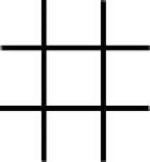

**FLOWCHART:**

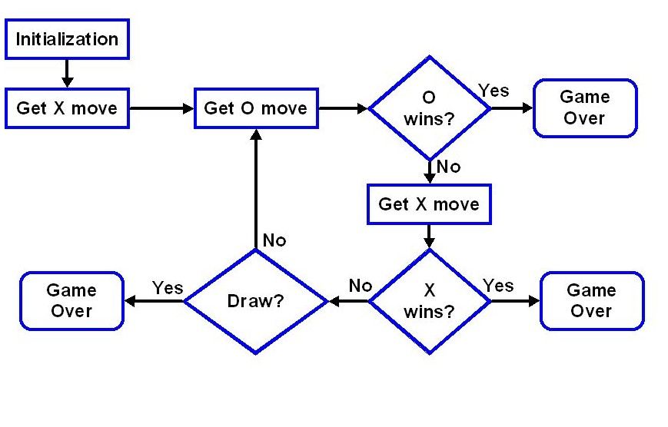

**RESULT:**

That kind of instant knowledgeis great for human beings, because it makes you a fast player.At last Tic Tac Toe game successfully implemented with the help of C language and it is very entertaining.

**OUTPUT**

